**PRACTICAL: 3**

**GAS CHROMATOGRAPHIC SEPARATION OF VOLATILE SAMPLE**

**DATE:22/07/22**

**AIM:**

To separate the components by gas chromatographic technique: Separation of methanol and ethanol

**INTRODUCTION:**

Gas chromatography is a term used to describe the group of analytical separation techniques used to analyse volatile substances in the gas phase. In gas chromatography, the components of a sample are dissolved in a solvent and vaporized in order to separate the analytes by distributing the sample between two phases: a stationary phase and a mobile phase. The mobile phase is a chemically inert gas that serves to carry the molecules of the analyte through the heated column. Gas chromatography is one of the sole forms of chromatography that does not utilize the mobile phase for interacting with the analyte. The stationary phase is either a solid adsorbant, termed gas-solid chromatography (GSC), or a liquid on an inert support, termed gas-liquid chromatography (GLC). Gas chromatography is an instrumental technique used forensically in drug analysis, arson, toxicology analyses of other organic compounds.

Diclofenac is a nonsteroidal anti-inflammatory drug (NSAID). This medicine works by reducing substances in the body that cause pain and inflammation. Diclofenac is used to treat mild to moderate pain, or signs and symptoms of osteoarthritis or rheumatoid arthritis. Voltaren is also indicated for the treatment of ankylosing spondylitis. The Cataflam brand of this medicine is also used to treat menstrual cramps.

Diclofenac powder (Cambia) is used to treat a migraine headache attack. Cambia will only treat a headache that has already begun. It will not prevent headaches or reduce the number of attacks.

**PRINCIPLE:**

In gas-solid chromatography, solid adsorbent is used as a stationary phase & separation takes place through adsorption process while in gas- liquid chromatography, the stationary phase consists of thin layer of non-volatile liquid bound to solid support & separation takes place through the process of partition. Gas-liquid chromatography is most commonly used technique. The sample which is to be separated is first converted into vapours & thus mixed with gaseous mobile phase. Components of a sample that are more soluble in stationary phase travels slower & the components that are less soluble in stationary phase travels faster. The components are thus separated according to their partition co-efficient.

**INSTRUMENTATION:**

Generally, all the chromatographs (GSC or GLC) consists of six basic components:

1. Sample injection system: A sample port is necessary for introducing the sample at the head of the column. A calibrated microsyringe is used to transfer a volume of sample through a rubber septum and thus into the vaporization chamber. Most of the separations require only a small fraction of the initial sample volume and a sample splitter is used to direct excess sample to waste. Commercial gas chromatographs involve the use of both split and splitless injections when alternating between packed columns and capillary columns. The vaporization chamber is typically heated 50 °C above the lowest boiling point of the sample and subsequently mixed with the carrier gas to transport the sample into the column.
2. Carrier Gas: A carrier gas plays a vital role in GC. It should be inert ,dry & free of oxygen. Helium, Nitrogen, argon & hydrogen gases are used as carrier gas depending upon the desired performance & detector being used. Carrier gas is supplied at high pressure & is passed to instrument at a rapid & reproducible rate.
3. Separation column: Open tubular columns or capillary columns & packed columns are used in GC. The first type of capillary column is a wall-coated open tubular (WCOT) column and the second type is a support-coated open tubular (SCOT) column. WCOT columns are have a thin layer of the stationary phase coated along the column walls. In SCOT columns, the column walls are first coated with a thin layer of adsorbant solid, such as diatomaceous earth, a material which consists of single-celled, sea-plant skeletons. The adsorbant solid is then treated with the liquid stationary phase. While SCOT columns are capable of holding a greater volume of stationary phase than a WCOT column due to its greater sample capacity, WCOT columns still have greater column efficiencies. One of the most popular types of capillary columns is called the coated Fused Silica open tubular column.
4. Column Oven or Thermostat chambers: The thermostat oven is there to control the temperature of the column to conduct precise work. The oven can be operated in two manners: isothermal programming or temperature programming. In isothermal programming, the temperature of the column is held constant throughout the whole separation. In the temperature programming method, the column temperature is either increased continuously or in steps as the separation progresses.
5. Detectors: Most common types of detectors used in GC are: Mass Spectrometer, Flame ionization detector (FID), Electron capture detector (ECD), Thermal conductivity detector (TCD), Atomic emission detector (AED), Photoionization detector (PID), Chemiluminescence detector. Detector is present at the end of the column & gives the quantitative measurement of the components of the mixture as they elute in combination with the carrier gas.
6. Amplification & Recorder system: These are the last & final components of GC instrumentation. These are meant to record the signals that come from the detector. These use special electronic circuits the process & amplify the signals so as to display in an understandable graphical format that represents several peaks of the constituents of the sample under analysis
7. Carrier Gas Types: Carrier gas is an inert gas used to carry samples. Helium (He), nitrogen (N2), hydrogen(H2),andargon(Ar)areoftenused.  
   Helium and nitrogen are most commonly used and the use of helium is desirable when using a capillary column.

|  |  |
| --- | --- |
| **Helium** | Although expensive, it is safe and has a relatively wide optimum linear velocity range. |
| **Nitrogen** | Although it is safe and its cost is reasonable, it has disadvantages such as a narrow optimum linear velocity range and a low optimum linear velocity that requires more analysis time. |

As carrier gas constantly flows into the detector, high-purity gas of at least 99.995 % needs to be used.

**SOFTWARE USED:**

GC-2014 Analysis Systems

**APPLICATIONS:**

GC has wide range of applications in various fields. It has a medicinal & pharmaceutical application. It is used in food, beverage, flavour & fragrance analysis. It is also helpful in environmental analysis and monitoring. It is used to detect doping of drugs. In forensics, it is used in cases of arson, detection of body fluids, for the testing of fibre, blood alcohol, detection of poisons, pesticides & also to detect explosives residues. It is also useful in Security and chemical warfare agent detection.

**The application of gas chromatography to environmental analysis**: GC has significant role in the identification & quantification of pollutants of environment. Capillary GC is used in the analysis of various classes of persistent organic contaminants in air, water, soils, sediments and biota. The organic pollutant groups like volatile organic compounds (VOCs); polycyclic aromatic hydrocarbons (PAHs); pesticides; and halogenated compounds such as polychlorinated dibenzo-p-dioxins and dibenzofurans, polychlorinated biphenyl, terphenyls, naphthalene and alkanes, organochlorine pesticides, and the brominated flame retardants, polybrominated biphenyls and polybrominated diphenyl ethers are analysed by GC.

**Application of gas chromatography in food analysis**: Gas chromatography (GC) is widely used in food analysis. Quantitative and qualitative analysis of food composition, natural products, food additives, flavor and aroma components, a variety of transformation products and contaminants, such as pesticides, fumigants, environmental pollutants, natural toxins, veterinary drugs, and packaging materials are done through GC.

**Application of GC in catalysis**: Determination of the physicochemical properties of solid catalysts and adsorbents, catalyst evaluation and kinetics of catalytic reactions, and study of catalytic reactions are done under chromatographic conditions. GC is 110 longer to be regarded merely as an analytical tool for the quick (and, if necessary, continuous) determination of product composition, but as an essential part of an integrated program of kinetic analysis, including the determination of reaction parameters as well as diffusional constants. GC can be used in the study of catalysis in two ways. In the first, the catalyst under study is packed in a chromatographic column, and the properties are estimated by the chromatographic parameters such as retention time, retention volume, band width and shape, and behavior of the chromatographic peak; while in the second, a micro reactor, in which a catalytic reaction or certain measurements on the catalyst are carried out, is directly connected to the chromatographic system whose function is to provide a rapid analysis of feed and products of the catalytic process.

**GC analysis of petroleum products:** The petroleum products such as jet fuel petrol, diesel, kerosene are also analysed through GC. Test parameters involves column- supeul –Q PLOT, oven-35 degree celsius, 16 degree per min. to 250 degree Celsius, detector – TCD, carrier gas – He ,sample-jet fuel. GC analysis of water ib gasoline is also done.

**OTHER COMMON APPLICATIONS:**

* Identification of hazardous compounds in waste damps.
* Quantification of drugs & their metabolites in blood & urine for both pharmacological &
* forensic applications.
* Identification of reaction products.
* Quantification of pollutants in drinking & waste water.
* Analysis of industrial products for quality control.
* Skin sample analysis.
* RNA isolation.
* Astro chemistry & geochemical search

**OBSERVATIONS:**

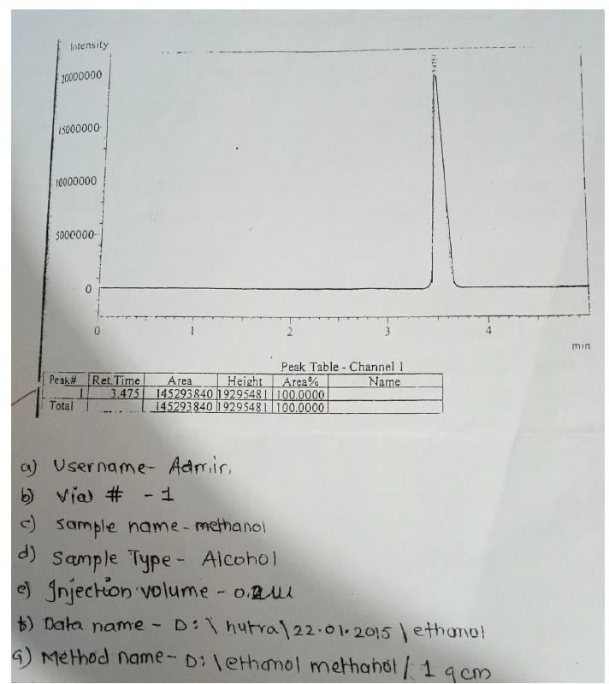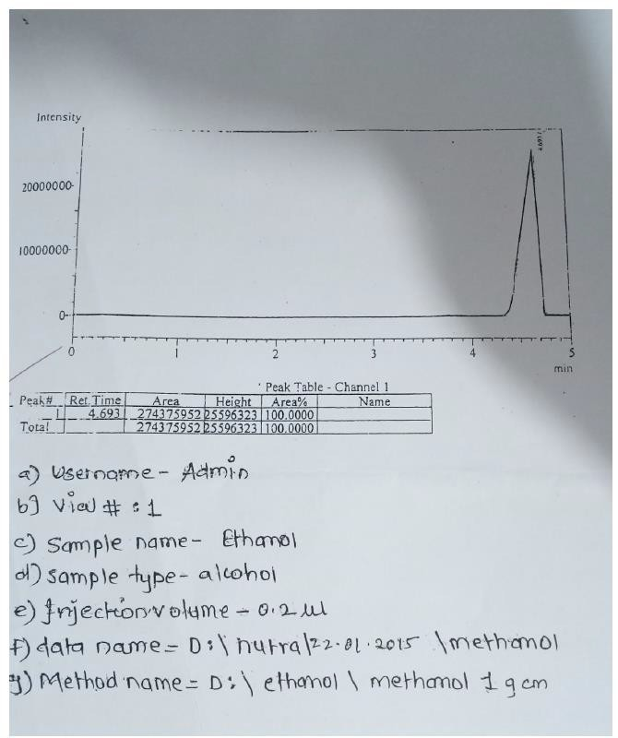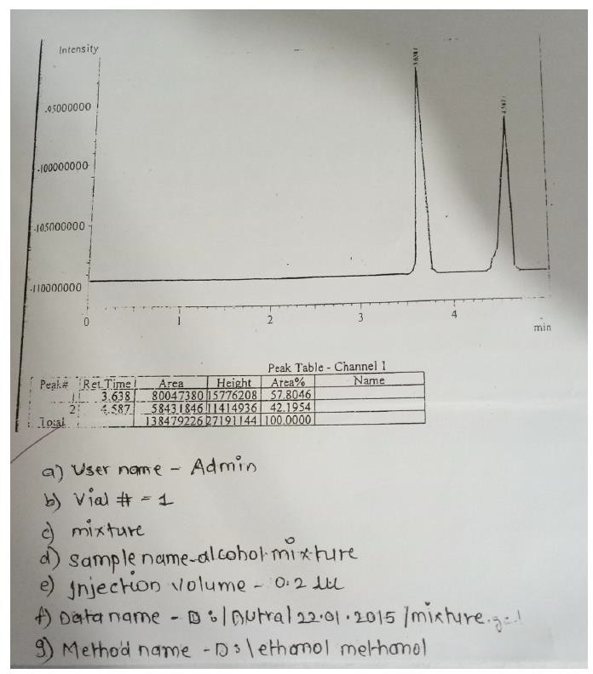

**RESULT:**

In the mixture of alcohol, Rt of peak 1 match with that of standard methanol and peak 2 matches with that of standard ethanol. Since, under the identical chromatographic conditions, the Rt of the individual solutes in the given mixtures is matching with that of standard. It can be concluded that peak 1 is of methanol and peak 2 is of ethanol. Thus, the mixture of closely related volatile alcohol was successfully separated by GC. The individual solvents were identified from the mixtures by matching the Rt values with that of standard.

**CONCLUSION:**

Thus, it can be concluded that at present, GC is the most widely used analytical technique available for separations & identifications of compounds or complex mixtures. The factors that makes GC most widely used technique are its speed, good resolving power, sensitivity with few mg of sample, good precision & accuracy.